FPT University

**Classifying pests for plants using MobileNetV3**

DAP391m_Group 1_Project

| **GROUP 1** | |
| --- | --- |
| **Group Members** | **Đỗ Tiến Đức**  **Nguyễn Hồng Sơn**  **Ngô Đình Hoàng Minh** |
| **Supervisor** | **Phan Duy Hùng** |

Acknowledgement

Our appreciation for Mr. Phan Duy Hùng, our instructor, is beyond words. Without his help and commitment to every stage of the process, we would not have been able to undertake this project. Although we have only studied for around two months, we have made significant progress in our understanding and application of machine learning and image processing techniques. Using the information and abilities we have received from our teachers, we have successfully developed our "Pests classification for plants using MobileNet V3" presentation, which has been our greatest effort yet.

We are also grateful to our classmates AI1807, who have been with us and helped us a lot during this time. Thank you for working together, and thank you for being a part of our happy memories in FPT University. We wish the class AI1807 a successful exam and good luck.

Abstract

Classifying pests for plants is critical in precision agriculture because it enhances crop health and yield by promptly and accurately identifying pest infestations. In this research, we look at how transfer learning can be applied using a state-of-the-art convolutional neural network (CNN) called MobileNetV3 for pest classification on plants. With Full utilization of its pre-trained model, MobileNetV3 which was initially trained with the ImageNet dataset, the model was fine-tuned to suit our custom dataset of plant pest images. To maintain its learned feature extraction capabilities by freezing the base layers of MobileNetV3 and adding custom dense layers for pest classification as a specialized task are main steps in this methodology. Overfitting was countered through augmentation techniques that provided extensive data augmentation to make the model more robust. This demonstrated that it could be successfully used in real world agricultural conditions where different classes of insects needed identification thus making an efficient approach to detecting pests within various fields such as crops or greenhouses. This way, it can become affordable for farmers dealing with pesticides since they will be able to detect their presence automatically instead of applying them manually.

**Keywords:** Pests and Diseases Identification; Precision Agriculture; Crop Insect Detection

# I. INTRODUCTION

## Problem and Motivation

In agriculture, especially in the horticulture sector, pests pose a significant threat to crop health and productivity. Accurate identification and classification of pests is vital for farmers and agricultural professionals to carry out targeted pest control measures. Current pest classification methods often rely on manual inspection, which can be time-consuming and prone to human error. Currently, there are no breakthrough technologies and tools in this field to accurately identify and classify pests. Therefore, there is an urgent need for a reliable and effective system that can accurately classify pests affecting crops, including those commonly found in Vietnamese agricultural environments, to assist farmers in effectively managing pest infestations and ensuring optimal crop health and yield.

# Related worked

The results of some researches have been found such as: Detecting thrips in strawberry greenhouses is vital for crop health [1]. Traditional methods are labor -intensive, leading researchers to use image processing and Support Vector Machine (SVM) classification. A study utilized canopy images and SVM with various kernels, using the ratio of the major diameter to the minor diameter as a region index, along with Hue, Saturation, and Intensity (HSI) as color indices. This method achieved a mean percent error of less than 2.25%, demonstrating high effectiveness in thrips detection, enabling timely pest control and improved yields [2]. Machine learning offers efficient insect classification, a task traditionally requiring expert taxonomists. Techniques such as ANN, SVM, KNN, NB, and CNN were applied to datasets like Wang, Xie, Deng, and IP102. Notably, the CNN model achieved 91.5% accuracy for nine classes and 90% for 24 classes using 9-fold cross-validation. An algorithm involving foreground extraction and contour identification enhanced performance, enabling early insect detection and better crop management [3].Hyperspectral and multispectral sensing technologies provide detailed crop data, aiding in management, yield forecasting, and disease detection. These methods generate large data volumes, necessitating advanced processing techniques. The review highlights the integration of Big Data analytics, machine learning, and deep learning to handle this data. Techniques such as ensemble machine learning and scalable parallel discriminant analysis show promise in improving agricultural productivity through enhanced data analysis [4].A geometric model can predict the occurrence of insect pests, taking into account air temperature and relative humidity.

The sensor device has cameras that monitor insects and analyze images online. The model tested several types of technical analysis, achieving accuracy as high as 76.5%. Extending the model to consider three- and five-day time periods improved accuracy to 86.3% and reduced false detections to 11%. This approach assists farmers in discovering timely response insights, saving time and resources.These examples represent the application of modern technologies such as image processing, machine learning, and Big Data analytics in the agricultural sector, to improve efficiency. pest detection and management.

This article aims to present a machine learning model that allows predicting and classifying insect pests that damage crops based on images. This model is especially important because it offers the potential to help farmers detect and identify harmful insects automatically and effectively. Using images, the model provides a reliable tool to reduce the need for time and expertise from farmers, while also providing vital information to help manage and conserve water and protect plants effectively

## Contribution

The main contribution of this paper is to develop a comprehensive classification system for plant pests, which has been meticulously studied and evaluated to identify the most effective categorization methods for enhancing pest management strategies. This system is divided into 3 parts: Methodology, Experiment and Results, and Conclusion. Methodology is the section which methodologies of our research focuses on in order to improve the understanding and management of plant pests. The ecological interactions are particularly optimized for agricultural ecosystems.

As an additional contribution, a pest management application compatible with various agricultural settings is developed. Users can input data about pest sightings or select from a pre-existing database. Then, the application performs classification, risk assessment, and suggests management practices automatically. The results are stored in a user-friendly format, allowing farmers and agronomists to track pest occurrences, implement control measures, and share information with other stakeholders. The application also includes a synchronization function to update data across multiple devices.

We tested our proposed classification system and application to verify their effectiveness. This study includes results and comparisons with existing pest management frameworks.

# II. Methodology

The Convolutional Neural Network (CNN) architecture has been used in this paper for the detection and classification of insects. 9 categories of insect images are chosen, and features are subsequently extracted from each image using CNN.

CNNs show reliable development in accuracy with increasing parameters, without giving indications of overfitting or performance degradation. Under various circumstances, it has achieved optimized results over various datasets. Moreover, CNNs need considerably fewer parameters and less processing time for better performances.

In each layer, different features are extracted and fed to the next layer. The methodology is organized as follows:

(i) Data Preprocessing and Augmentation: Data preprocessing is a data mining procedure that involves transforming raw data into a logical format.

(ii) Import required modules: Modules define classes, functions, and variables that can be used by other Python files by importing.

(iii) Design Networks: Instantiates the CNN architecture.

(iv) Defines the loss function, optimizer, and evaluation metrics.

(v) Execution: Training the overall model.

## 1. Depthwise Convolutions

Depthwise convolution is a particular type of convolution that applies a single filter for every input channel at a time in contrast to a standard convolution. Hence, as per the below figure illustrating depthwise convolutions, considering we have a filter of size Dk×Dk×1, to obtain a dimension of size M we would need M such filters. Total number of multiplications needed: M×D2k×D2p. Total number of parameters: M×Dk×Dk.

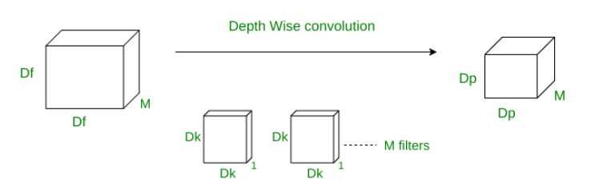

## 2. Squeeze and Excite blocks

The convolution operator plays a vital role in generating informative features by coalescing both spatial and channel information at neighboring receptive fields in each layer. There has been numerous research to enhance spatial encoding to improve network representational power. One technique developed was a squeeze and excite block aiming to unequivocally display the interdependencies between the channels of its convolutional highlights. It achieved this by enhancing feature maps that contribute to convolution and repressing the ones that do not. The below figure describes its mechanism. Feature maps from the previous layer are averaged pooled to produce an output of dimension 1×1×C, with C being previous layer channels. They are then passed through fully connected layers. The output of these fully connected layers are then multiplied with the initial input layer. MobileNet V3 is made up of inverted residual bottlenecks and squeeze and excite blocks. These are derived from MobileNet V2 and squeeze and excitation networks. Their architecture constitutes a 1×1 pointwise expansion layer, 3×3 or 5×5 depthwise convolution, and a 1×1 projection layer. To emphasize their architecture’s neurons that contribute to network performance and conceal neurons that do not, SE blocks are introduced.

## 3. Transfer Learning

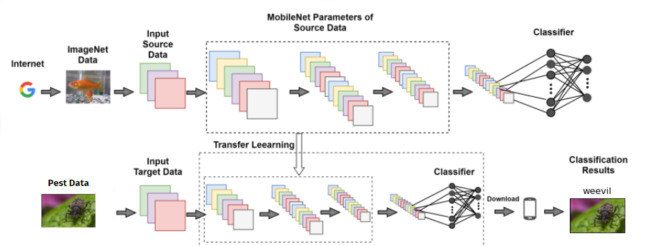

Transfer learning leverages the knowledge acquired from the ImageNet dataset to the new task of pest classification. The pre-trained MobileNetV3 model’s feature extractor is adapted to process the new target data, which in this case is a dataset of pest images affecting plants. The base layers of MobileNetV3 are typically frozen to retain the learned features from the ImageNet dataset. New layers (including a new classifier) are added to the model to handle the specific task of pest classification. These new layers are trained on the pest data to learn features specific to identifying different types of pests. The model parameters of these new layers are optimized to accurately classify pests. Once trained, the model can take new pest images as input and pass them through the fine-tuned MobileNetV3 network. The classifier provides the final output, identifying the pest in the image (e.g., a weevil).

## 4. Data Collection.

In the experiment, we are using the Agricultural Pest Image Dataset on kaggle, which is a collection of images of 12 different types of agricultural pests, each type having 300-500 images. Below are some examples from the dataset:

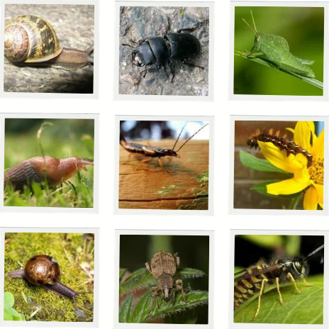

For more details, visit the website <https://www.kaggle.com/datasets/vencerlanz09/agricultural-pests-image-dataset>.

## 5.Training Model:

### 5.1. Data Split

The dataset was divided into training and test sets using the train_test_split function to ensure an appropriate distribution of data for model training and evaluation.

### 5.2. Data Augmentation

To enhance the robustness of the model, data augmentation was employed using the ImageDataGenerator class. This approach generated additional training images through random transformations, such as rotation, zooming, and flipping, to prevent overfitting and improve generalization.

### 5.3. Callbacks and Early Stopping

To control the training process, we utilized EarlyStopping and ModelCheckpoint callbacks. EarlyStopping was used to halt training when there was no further improvement in the validation accuracy, preventing overfitting. ModelCheckpoint was employed to save the model with the highest validation accuracy during training.

### 5.4. Model Training and Validation

The Convolutional Neural Network (CNN) model was trained for 100 epochs. The training process involved evaluating the model's performance on the training and test datasets after each epoch. The use of EarlyStopping ensured that training ceased once the model's performance plateaued, while ModelCheckpoint ensured that the best model, based on validation accuracy, was saved. This rigorous training and validation protocol resulted in a robust and effective model for pest classification.

## 6. Effects and Result analysis

### 6.1 Technology and Modules

The simulation is performed on anaconda platform using Python programming language.The use python modules are

**TensorFlow and Keras:** For building and training the neural network.

**Numpy and Pandas:** For numerical operations and data manipulation.

**PIL (Python Imaging Library) and keras_preprocessing.image:** For image processing and data augmentation.

**Scikit-learn:** For machine learning algorithms and evaluation metrics.

**Matplotlib:** For data visualization.

### 6.2 Experimental Results

The model trained for 100 epochs achieved significant results. Below are the key metrics from the training process:

During the training process, the model's accuracy on both the training and validation datasets increased, while the loss decreased significantly. This indicates that the model learned important features from the data and has good generalization abilit**y.**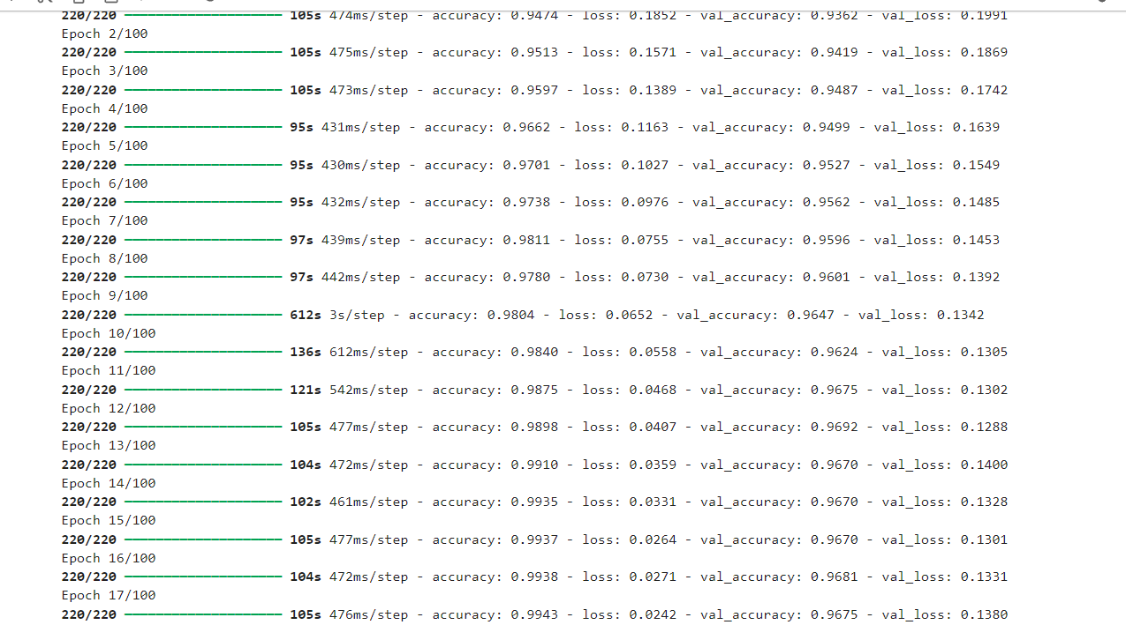

#### 

#### The model achieved a highest accuracy of 99.43% on the training set and 96.92% on the validation set after 17 epochs. The lowest loss achieved was 0.0242 on the training set and 0.1288 on the validation set.

By providing these metrics, we demonstrate that our CNN model effectively and accurately classifies insects.

### 6.3 Evaluation Metrics:

The model's performance was evaluated using precision, recall, and F1-score metrics for each class of insects. The table below summarizes these metrics for the various insect categories

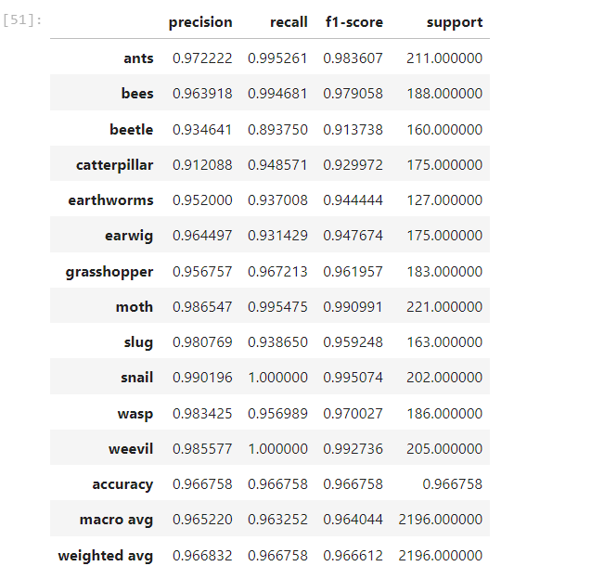

The overall accuracy of the model was 96.67%, with a macro average precision of 96.52%, recall of 96.33%, and F1-score of 96.40%. The weighted average precision was 96.68%, recall was 96.68%, and F1-score was 96.66%.

These metrics demonstrate that the model has high accuracy and performs well across different insect classes, showing its robustness and generalization ability.

# III.Conclusion

MobileNetV3 is a tool that is very effective in classifying pests and has achieved a balance between good performance and efficiency. In this project, the model’s overall accuracy was excellent at 96.68% due to its strong performance on various pests. The majority of classes had astonishing precision, recall, and F1 scores which showed how the model could correctly recognize different types of pests. For example, Snail had a perfect recall value of 1.000 and an F1-score of 0.995, while Weevil also recorded perfect recalls with F1-scores amounting to 0.992736. On the other hand, Moth achieved an amazing F1-score of 0.990991 which shows almost perfect classification efficacy.

# 

# REFERENCES

**[1].** Ebrahimi, M. A., Khoshtaghaza, M. H., Minaei, S., & Jamshidi, B. (2017). Vision-based pest detection based on SVM classification method. Computers and Electronics in Agriculture, 137, 52–58. doi:10.1016/j.compag.2017.03.016

**[2].** Thenmozhi Kasinathan, Dakshayani Singaraju, Srinivasulu Reddy Uyyala, Insect classification and detection in field crops using modern machine learning techniques, Information Processing in Agriculture, Volume 8, Issue 3, 2021, Pages 446-457,ISSN 2214-3173.

**[3].** Hruška, J., Adão, T., Pádua, L., Marques, P., Cunha, A., Peres, E., … Sousa, J. J. (2018). Machine learning classification methods in hyperspectral data processing for agricultural applications. Proceedings of the International Conference on Geoinformatics and Data Analysis - ICGDA ’18.

**[4].** Marković, D., Vujičić, D., Tanasković, S., Đorđević, B., Ranđić, S., & Stamenković, Z. (2021). Prediction of Pest Insect Appearance Using Sensors and Machine Learning. Sensors, 21(14), 4846.

**[5].** Tangtisanon, P., & Kornrapat, S. (2020). *Holy Basil Curl Leaf Disease Classification using Edge Detection and Machine Learning. Proceedings of the 2020 12th International Conference on Computer and Automation Engineering.* doi:10.1145/3384613.3384634

**[6].** Brunelli, D., Albanese, A., d’ Acunto, D., & Nardello, M. (2019). *Energy Neutral Machine Learning Based IoT Device for Pest Detection in Precision Agriculture. IEEE Internet of Things Magazine, 2(4), 10–13.* doi:10.1109/iotm.0001.1900037

**[7].** Ayan, E., Erbay, H., & Varçın, F. (2020). *Crop pest classification with a genetic algorithm-based weighted ensemble of deep convolutional neural networks. Computers and Electronics in Agriculture, 179, 105809.* doi:10.1016/j.compag.2020.105809

**[8].** Thenmozhi, K., & Srinivasulu Reddy, U. (2019). *Crop pest classification based on deep convolutional neural network and transfer learning. Computers and Electronics in Agriculture, 164, 104906.* doi:10.1016/j.compag.2019.104906

**[9].** Hieu T. Ung, Huy Q. Ung, Binh T. Nguyen (2021). An Efficient Insect Pest Classification Using Multiple Convolutional Neural Network Based Models.

**[10].** Performance of MobileNetV3 Transfer Learning on Handheld Device-based Real-Time Tree Species Identification.